**FLUID MANAGEMENT IN CHILDREN**

## Introduction

The main aim of the perioperative fluid strategy is to maintain “homeostasis” by re‑establishing normal physiology through central euvolemia and providing adequate electrolytes based on the child’s need due to various deficits like preoperative fasting, losses due to renal, cutaneous, gastrointestinal, and third space losses.

## Physiological difference between adults and children

Children have a higher metabolic rate, larger surface area to weight ratio and faster respiration resulting in extensive fluid losseswhich translates to higher fluid requirement.

Around 50 to 80% of the body is water, and the percentage is inversely proportional to age.

Extracellular fluid( ECF) is usually larger and further divided into 3 compartments: plasma, interstitial, and transcellular.

In preterm infants, the ECF is around 80% and reduces to around 60% by 6 months of age.

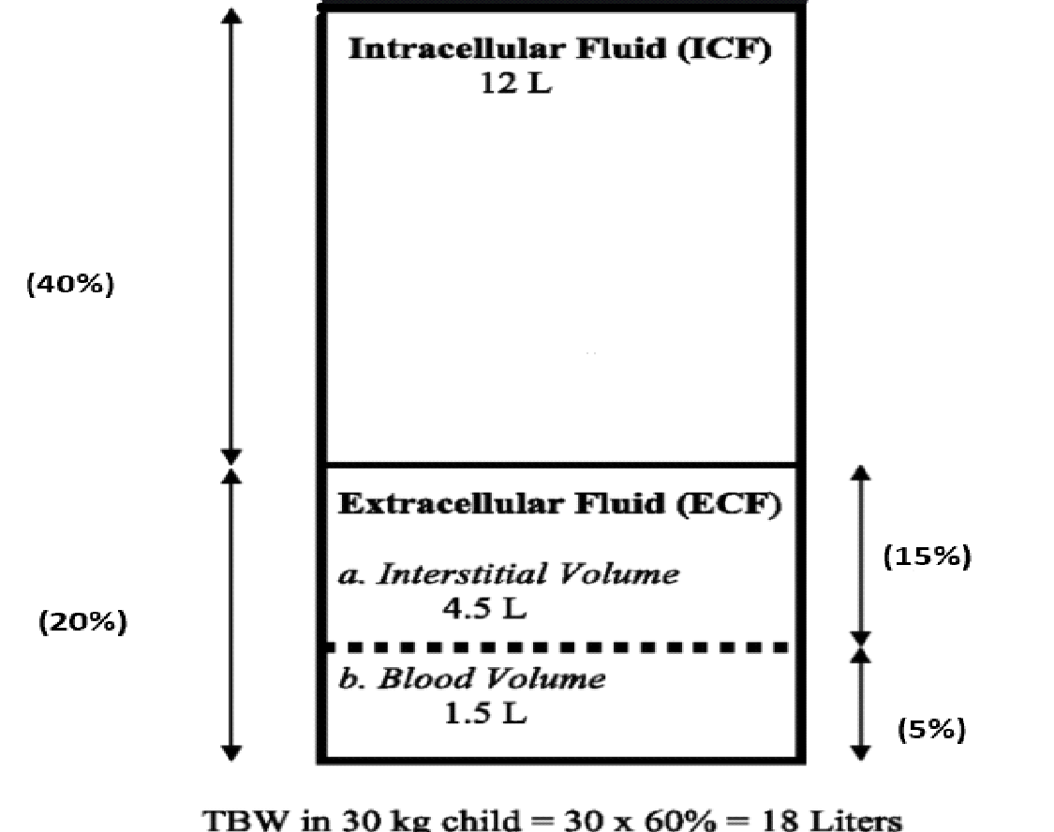

The distribution of ions and fluids between the ECF and ICF compartment is governed by the Donnan effect and Starling forces.

Assessment of fluid deficit

1. Clinical assessment

| **Table 3: Assessment of Dehydration in Pediatrics** | | | |
| --- | --- | --- | --- |
| **Severity of Dehydration** | **% Dehydration** | | **Symptoms** |
| **Infant** | **Child** |
| Mild | 5 | 3-4 | Thirst. Mucous membranes moist, EJV visible in supine, CRT >2 sec, Urine sp gr >1.020 |
| Moderate | 10 | 6-8 | Dry mucous membranes, ↑ HR, ↓ tears, Sunken fontanelle, Decreased skin turgor, CRT 2-4 sec, ↓Urine Output |
| Severe | 15 | 10 | Eye sunken, cool peripheries, apathy, somnolence, orthostatic to shock |
| Shock | >15 | >10 | Decompensation, Poor O2 delivery, ↓BP |

1. Urine Output -

can be an indication of hydration status. Experienced pediatric anesthetists are comfortable with at least 0.5 ml//hr. of urine output per hour.

1. IVC USG scan

To assess fluid responsiveness,

* An autotransfusion manoeuvre like pressure on the liver or passive leg raising can be performed.
* Blood pressure curve variations over the breathing cycle (systolic blood pressure variation, pulse pressure variation)
* The perfusion index or pleth variability index calculated based on pulse oximetry
* Echocardiographic measurements are additional aids to assess fluid responsiveness.

**What routes can be utilized to prevent fluid deficits ?**

Enteral Feeding

Fasting should be minimized to 6 hours for solids, 3 hours for mother’s milk and 1 hour for water / clear fluids.

Initiate the oral feeds safely in the postoperative period as soon as possible. Once the child is awake, can be orally fed until and unless there is a contraindication to feed.

Parenteral Infusion of fluids

Intraoperative and perioperative periods need the IV infusion of fluid to cover for prolonged fasting periods, resuscitation, maintenance, replacement for losses and other losses. Intravenous fluids are initiated when oral intake is not sufficient in the perioperative period.

Access

* Peripheral IV
* Midline IV
* Central IV

## What fluid should be infused perioperatively?

The recent updates in shortening the preoperative fasting times in children should be extended into the post-operative period too. Children should be encouraged to restart oral fluids as early as possible if there is no surgical contraindication, however fluid intake need not be insisted before discharge from an ambulatory facility.

Postoperative IV infusions should best be with isotonic fluids

## How much fluid should be infused perioperatively?

Holliday and Segar’s recommendation is a decent guide to paediatric fluid management provided the surgical catabolic state and stress are kept in mind.

Because of such concerns, current recommendations have moved towards the use of total volume infusion to be restricted to 50% of isotonic solutions with a glucose requirement of 1-2.5%.

## Intraoperative Fluid Management

Resuscitation Fluid-to correct pre-existing hypovolaemia or dehydration

Hypovolaemia (losses from the intravascular space) should be replaced initially with 10- 20 ml/kg boluses of isotonic solutions like Plasma-Lyte® A/ Ringer Lactate. In children with hypochloremia such as those with severe gastroenteritis or vomiting, the use of isotonic normal saline can be considered. Blood should be considered if the haemoglobin is low, or there is ongoing bleeding, or more than 40 ml/kg of fluid is required.

Maintenance Fluid**-** to provide water, electrolytes and glucose during the starvation period. All the guidelines(APA,NICE) still follow the Holliday Segar Formula for maintenance therapy and they recommend infusion of isotonic solutions . NICE guidelines recommend restriction of fluids by 50 to 80 percent because of non-osmotic ADH secretion.

| **Body weight** | **Holliday and Segar** | **Oh** |
| --- | --- | --- |
| 1-10kg | 4ml/kg/hour | 4ml/kg/hour |
| 10-20kg | 40 ml/hour+2 ml/kg/hour  above 10 kg | 20 + (2x weight in kg) ml/kg/h |
| >20kg | 60 ml/hour+1 ml/kg/hour  above 20 kg | 40 + weight in kg ml/kg/h |

## Should we give Glucose containing fluids for maintenance?

Presently it is well accepted to use isotonic fluids with lower glucose concentration (1-2.5%)for children less than 2 years to maintain normal glucose concentrations and avoid lipolysis, hyponatremia and hypochloraemia especially in infants, liver disease and metabolic diseases.

These are children with high risk of developing hypoglycaemia as in preterm neonates, children receiving hyperalimentation, children with liver failure, patients with mitochondrial diseases and those with endocrinopathies.

Frequent glucose monitoring is essential for high risk for hypoglycaemia and small children.

For hyponatremia and hypochloraemia, adding 1-2.5% glucose can be considered as a background infusion especially in infants, liver disease and metabolic diseases.

Replacement Fluid-For ongoing losses

Replacement of intra operative blood losses with isotonic solution or blood will depend upon the haematocrit of the patient.

The 3rd space loss (its existence is a matter of debate) because of leaking of fluid from vascular space into tissues around the surgical site is difficult to account for and is roughly estimated as 2 ml/kg/h for superficial surgery, 4–7 ml/kg/h for thoracotomy and 5–10 ml/kg/h for abdominal surgery.

The most commonly available isotonic fluids include 0.9% Normal saline, Ringer Lactate and Plasmalyte. 0.9% saline is most commonly available and the cheapest fluid available, but it has a lot of chloride and no bicarbonate precursor.

If colloid is needed to be transfused though the indications are not very clear, 5% albumin remains the preferred colloid in young infants as it is iso‐oncotic to plasma and very effective to maintain blood pressure and plasma colloid perfusion pressure.

Age-specific considerations regarding the fluid transfusion

Initial 3 - 7 days of Neonatal period: Hypotonic fluid with 10% Dextrose is acceptable as the kidney and liver are very immature.

Special Situations

In the OT, the default fluid used for patients will be Ringer Lactate or Plasma-Lyte® A solution except in:

1. Neonates- Use Dextrose 5% or Dextrose 10% as maintenance drip, and use Plasma-Lyte® A, Normal Saline or Albumin 5%/ blood /blood products for volume resuscitation / replacement as appropriate to the clinical situation.
2. Neurosurgical cases- Normal Saline or Plasma-Lyte® A
3. Child on total parenteral nutrition (TPN)- continue TPN during surgery. Do not disrupt the sterility of the line used to administer TPN.

Key Messages

Minimising preoperative and postoperative fasting significantly impacts the comfort and hydration state of children. Early restarting of enteral feeding.

The main aim of fluid infusion is establishing euvolemia, adequate tissue perfusion and oxygenation.

Perioperative fluid prescription is very crucial in the management of critically ill children and should be guided by physiology and pathology.

Current recommendations have moved towards the use of total volume infusion to be restricted to 50% of the holiday and Segar calculation of isotonic solutions with a glucose requirement of 1-2.5% .